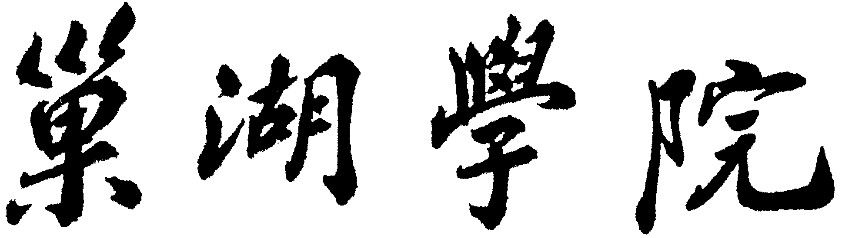



**题目：学生成绩信息管理系统数据库设计**

**专业：计算机科学与技术**

**班级：14计本一班**

**姓名：李恩民**

1. 需求分析
   1. 功能分析

管理系统包括学生信息，成绩信息，具体功能如下：

1. 学生信息的添加、查询、删除、修改。学生信息包括学号、姓名、性别、班级。实现了学生基本信息的录入，实现了按学号、姓名，班级号查询学生基本信息以及学生基本信息的更新。
2. 成绩信息的添加、查询、删除、修改。成绩信息包括学号、姓名、课程名称、成绩。实现了成绩信息的录入，实现了按学号、学生姓名、班级、课程名称查询学生成绩，按班级名称查询优秀率与不及格率，也实现了对成绩信息表的更新。
   1. 功能模块图

学生成绩管理系统

管理员

学生基本信息录入

所选科目成绩录入

所选科目成绩导出

基本信息查询

基本信息修改

信息数据管理

基本信息管理

成绩管理

成绩分析

成绩排名

每班单科平均成绩查询

每系单科平均成绩查询

每班单科及格率

每班单科优秀率

单科每班

单科每专业

总成绩排名

不及格统计

1. 概念设计

2.1 E-R图

**学生**

M

管理

1

管理员

1. 逻辑结构设计

3.1基本表

表3.1 root表

|  |  |  |  |  |  |
| --- | --- | --- | --- | --- | --- |
| 字段名 | 类型 | 是否空 | 主键\外键 | 默认值 | 备注 |
| rootId | Int(11) | no | 主键 |  | 管理员账户 |
| rootName | Varchar(20) | no |  |  | 管理员姓名 |
| rootPassword | Varchar(20) | no |  |  | 管理员密码 |

表3.2 student表

|  |  |  |  |  |  |
| --- | --- | --- | --- | --- | --- |
| 字段名 | 类型 | 是否空 | 主键\外键 | 默认值 | 备注 |
| Id | Int(11) | No | 主键 |  | 学生学号 |
| Name | Varchar(20) | No |  |  | 学生姓名 |
| Gender | Varchar(2) | No |  |  | 性别 |
| myClass | Varchar(10) | No |  |  | 班级 |
| English | Int(11) | No |  |  | 英语成绩 |
| Math | Int(11) | No |  |  | 数学成绩 |
| Chinese | Int(11) | no |  |  | 语文成绩 |

1. 系统实施

4.1 创建数据库及表的代码

Create database mydb3;

use mydb3;

drop table if exists student;

create table if not exists student(

Id int primary key not null,

Name varchar(20) not null,

Gender varchar(2) not null,

myClass varchar(10) not null,

English int not null,

Math int not null,

Chinese int not null

);

drop table if exists root;

create table if not exists root(

rootId int primary key not null,

rootName varchar(20) not null,

rootPassoword varchar(20) not null

);

4.2 导入测试数据

（1）root表

insert into root(rootId, rootName, rootPassoword)value(

123456，”root”,”root”);

（2）student表

insert into student(Id,Name,Gender,myClass,English,Math,Chinese)value(

12010101,"李乐","男","01班",80,90,80);

insert into student(id,Name,Gender,myClass,English,Math,Chinese)value(

12010102,"赵浩","男","01班",70,90,59);

insert into student(id,Name,Gender,myClass,English,Math,Chinese)value(

12010103,"张萌萌","女","01班",90,90,80);

insert into student(id,Name,Gender,myClass,English,Math,Chinese)value(

12010104,"涂琴","女","01班",60,70,70);

insert into student(id,Name,Gender,myClass,English,Math,Chinese)value(

12010105,"袁浩磊","男","01班",90,70,75);

insert into student(id,Name,Gender,myClass,English,Math,Chinese)value(

12010201,"刘明","男","02班",65,85,71);

insert into student(id,Name,Gender,myClass,English,Math,Chinese)value(

12010202,"胡蝶","女","02班",82,76,71);

insert into student(id,Name,Gender,myClass,English,Math,Chinese)value(

12010203,"吕燕","女","02班",87,84,83);

insert into student(id,Name,Gender,myClass,English,Math,Chinese)value(

12010204,"沈明","男","02班",53,95,76);

insert into student(id,Name,Gender,myClass,English,Math,Chinese)value(

12010205,"于琴","女","02班",69,85,64);

insert into student(id,Name,Gender,myClass,English,Math,Chinese)value(

12010301,"王小欧","女","03班",66,71,80);

insert into student(id,Name,Gender,myClass,English,Math,Chinese)value(

12010302,"马赛克","","03班",86,64,73);

insert into student(id,Name,Gender,myClass,English,Math,Chinese)value(

12010303,"高天宝","男","03班",71,82,62);

insert into student(id,Name,Gender,myClass,English,Math,Chinese)value(

12010304,"周梦晨","男","03班",93,94,90);

insert into student(id,Name,Gender,myClass,English,Math,Chinese)value(

12010305,"周翰龙","男","03班",62,84,51);

insert into student(id,Name,Gender,myClass,English,Math,Chinese)value(

12010401,"颜路","男","04班",88,65,52);

insert into student(id,Name,Gender,myClass,English,Math,Chinese)value(

12010402,"张正妮","女","04班",68,54,84);

insert into student(id,Name,Gender,myClass,English,Math,Chinese)value(

12010403,"徐华华","男","04班",54,32,65);

insert into student(id,Name,Gender,myClass,English,Math,Chinese)value(

12010404,"吴宇翔","男","04班",63,65,66);

insert into student(id,Name,Gender,myClass,English,Math,Chinese)value(

12010405,"张磊","男","04班",66,85,76);